Nitrate Forecasting Project – Summary of 2/18/2026 Meeting
Tag List
- IowaRiver_IowaCity_NitrateLevel – Hydro Info Lab sensors upstream of the water plant (data since 2012).
- WP_WC_Nitrate_River – Results of the water plant raw river nitrate test (every 4 hours).
- IowaRiver_IowaCity_Flow – River flow at Burlington Dam.
- IowaRiver_IowaCity_GaugeHeight – River height (ft) at Burlington Dam.
- IowaRiver_BelowCoralvilleDam_Flow
- IowaRiver_BelowCoralvilleDam_GaugeHeight
- CoralvilleReservoir_USACE_Outflow_Forecast
- CoralvilleReservoir_USACE_Level_Forecast
- CoralvilleReservoir_USACE_Level
- CoralvilleReservoir_USACE_Outflow
- CoralvilleReservoir_USACE_Inflow_Davg
Weather Station Data
West Chiller Plant Weather Station – Air temp functional; other sensors questionable.
- Air Temp: \piserver.facilities.uiowa.edu\WCP_00_TT_091 (°F)
- Relative Humidity: \piserver.facilities.uiowa.edu\WCP_00_MT_091 (%)
- Precipitation: \piserver.facilities.uiowa.edu\WCP_00_LS_091 (in)
Iowa City Municipal Airport (since 2025):
- Air Temp: \piserver.facilities.uiowa.edu\IowaCityAirport_Weather_Temperature (°C)
- Humidity: \piserver.facilities.uiowa.edu\IowaCityAirport_Weather_RelativeHumidity (%)
- Precipitation: \piserver.facilities.uiowa.edu\IowaCityAirport_Weather_Precipitation_Dtot (mm)
Outside Sources of Data
- Synoptic – free academic weather data.
Synoptic Data | Home
- Iowa Water Quality Information System (IWQIS).
Iowa Water Quality Information System | IWQIS
- Coralville Reservoir:
Rivergages.com - Station Information ForCoralville Lake Reservoir
- I-Canopy System – Professor Jun Wang of the College of has tools available that may be useful for this project. There is soil moisture, soil temp, humidity, temp, downloadable data.
Real-time Earth System Modeling Complex
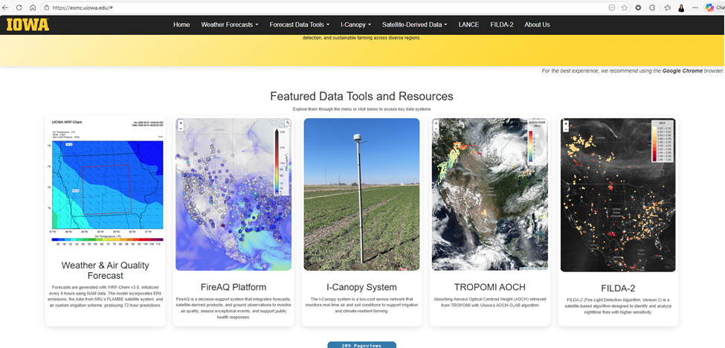
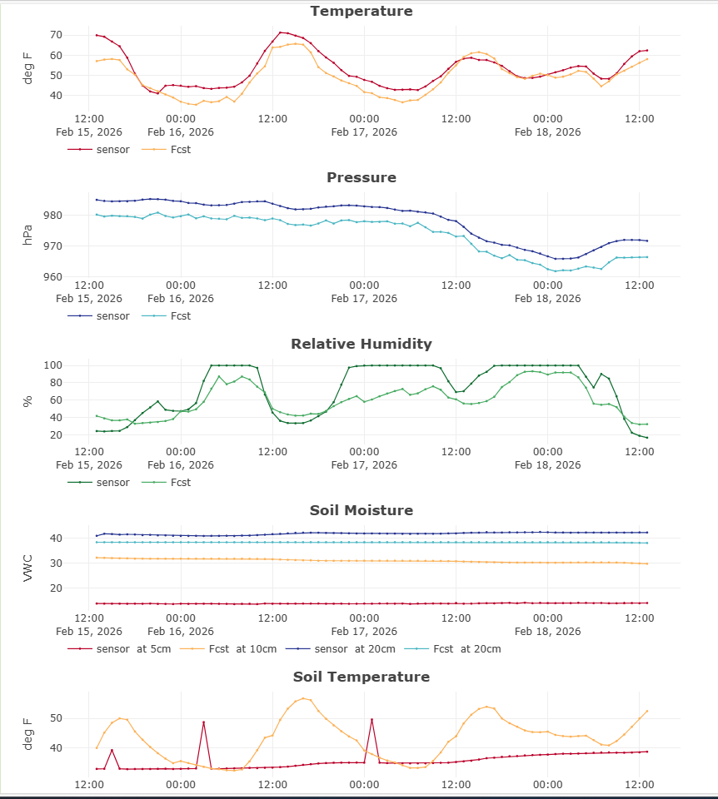

Tools
- PI System Explorer – Installer: Pi-AF-Client_2024 (on shared drive).
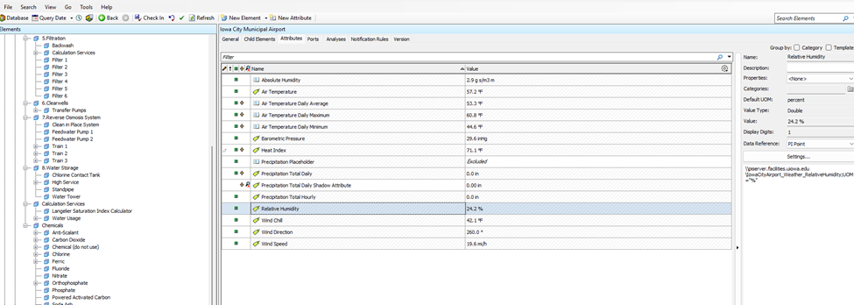
Installable tool with windows machine. Installer can be found on Iowa Shared Drive listed below.
\\iowa.uiowa.edu\shared\fm\Campus\PI
Installer: Pi-AF-Client_2024
*Download Pi-AF-Client_2024
You will be asked to questions:
PI Server: piserver.facilities.uiowa.edu
PI AF Server: pi-af.facilities.uiowa.edu

- PI DataLink – Excel add-in (installer: AVEVA-Pi-DataLink_2023_SP1).
Installable tool with windows machine. Installer can be found on Iowa Shared Drive listed below.
\\iowa.uiowa.edu\shared\fm\Campus\PI
Installer: AVEVA-Pi-DataLink_2023_SP1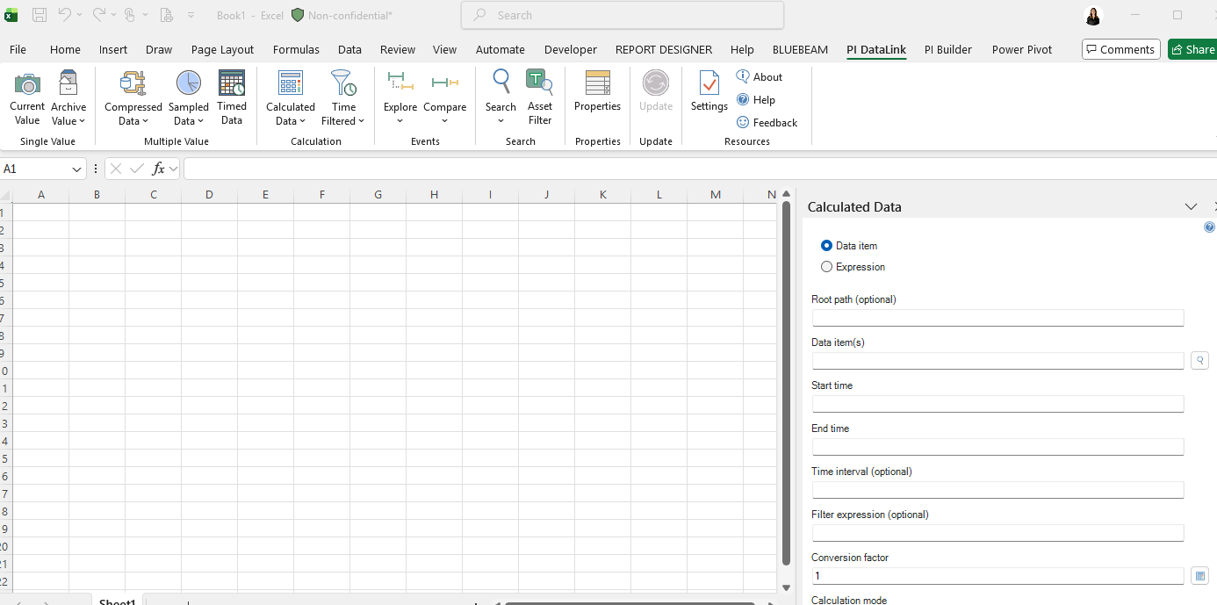

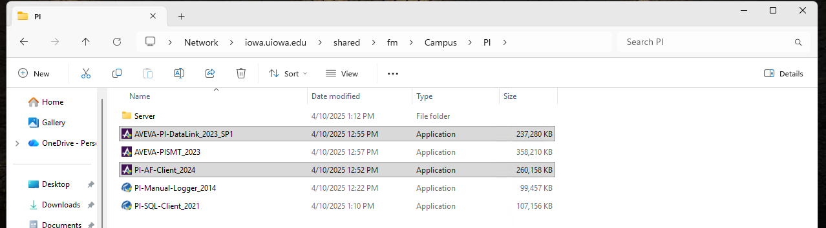

- PI Vision (web): https://pi-vision.facilities.uiowa.edu/PIVision/
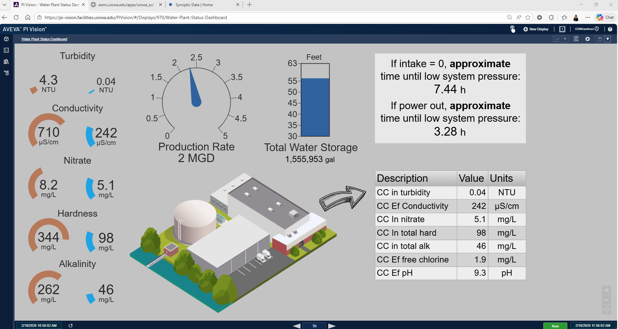
Currently available on the web to anyone with a HawkID.

PI Web API:
- Base Url: https://pi-vision.facilities.uiowa.edu/piwebapi
- Documentation: PI Web API Reference
- How to lookup a tag: https://pi-vision.facilities.uiowa.edu/piwebapi/points?path=\\piserver.facilities.uiowa.edu\MY_TAG_NAME
  - When you look up a tag you will get some metadata (i.e. units, description, etc.) and some links to use for pulling data. InterpolatedData, RecordedData (Raw data), and SummaryData (Min/Max/Avg/etc.). Pass in additional parameters through the url to configure your data pull

